📘 Java Project: Weekly Meal Planner & Grocery Generator
Abstract
The Weekly Meal Planner & Grocery Generator is a Java-based application designed to simplify meal planning and grocery shopping. It integrates computational thinking, object-oriented design, string manipulation, file I/O, and functional programming concepts. Users can input weekly meals, generate categorised grocery lists, and manage recipes efficiently. The project demonstrates how Java fundamentals (arrays, control flow, methods, recursion) evolve into advanced features (OOP, exceptions, collections, streams), providing a complete learning path from problem-solving to real-world application.
Advantages
🥗 Health & Nutrition
- Balanced meals with proper nutrients.
- Supports dietary restrictions (keto, gluten-free, diabetic).
- Encourages portion control and healthy habits.
⏱️ Time Efficiency
- Eliminates daily “what to cook” decisions.
- Auto-generated grocery lists save shopping time.
- Organised planning reduces cooking effort.
💰 Cost Savings
- Prevents unnecessary purchases.
- Suggests budget-friendly substitutions.
- Minimises food waste by reusing leftovers.
📂 Convenience & Organisation
- Categorised grocery lists (produce, dairy, grains).
- Easy customisation for individuals or families.
- Syncs with apps for reminders and inventory tracking.
🌱 Sustainability
- Promotes seasonal/local produce.
- Reduces food waste.
- Encourages eco-friendly shopping habits.
🔧 Adaptability
- Suitable for students, professionals, and families.
- Supports multiple cuisines and dietary preferences.
- Flexible enough for diverse lifestyles.
Implementation :
import java.util.*;
import java.io.*;

class Meal {
private String name;
private String[] ingredients;

Meal(String name, String[] ingredients) {
this.name = name;
this.ingredients = ingredients;
}

public String getName() { return name; }
public String[] getIngredients() { return ingredients; }

@Override
public String toString() {
return name + " -> " + Arrays.toString(ingredients);
}
}

public class WeeklyMealPlanner {
public static void main(String[] args) {
Scanner sc = new Scanner(System.in);

// Recipe book with dietary options
Map<String, String[]> recipeBook = new HashMap<>();
recipeBook.put("Pasta", new String[]{"pasta", "tomato", "cheese"});
recipeBook.put("Salad", new String[]{"lettuce", "tomato", "cucumber"});
recipeBook.put("Omelette", new String[]{"eggs", "onion", "tomato", "spinach"});
recipeBook.put("Smoothie", new String[]{"banana", "milk", "berries", "honey"});
recipeBook.put("Soup", new String[]{"chicken", "carrot", "celery", "onion"});
recipeBook.put("Sandwich", new String[]{"bread", "cheese", "ham", "lettuce"});
recipeBook.put("Stir Fry", new String[]{"chicken", "broccoli", "soy sauce", "garlic"});

String[] days = {"Mon","Tue","Wed","Thu","Fri","Sat","Sun"};
Map<String, Meal> weeklyPlan = new LinkedHashMap<>();

// Input dish for each day
for (String day : days) {
System.out.print(day + " dish: ");
String dish = sc.nextLine();
if (recipeBook.containsKey(dish)) {
weeklyPlan.put(day, new Meal(dish, recipeBook.get(dish)));
} else {
System.out.println("❌ " + dish + " not found in recipe book!");
weeklyPlan.put(day, new Meal(dish, new String[]{"No ingredients"}));
}
}

// Print weekly plan with ingredients
System.out.println("\n📅 Weekly Meal Plan with Ingredients:");
for (Map.Entry<String, Meal> entry : weeklyPlan.entrySet()) {
System.out.println(entry.getKey() + ": " + entry.getValue());
}

// Build grocery list (unique items)
Set<String> grocerySet = new HashSet<>();
for (Meal m : weeklyPlan.values()) {
for (String item : m.getIngredients()) {
grocerySet.add(item.trim());
}
}

// Categorise grocery items
Map<String, List<String>> categories = new LinkedHashMap<>();
categories.put("Produce", new ArrayList<>());
categories.put("Dairy", new ArrayList<>());
categories.put("Protein", new ArrayList<>());
categories.put("Grains", new ArrayList<>());
categories.put("Others", new ArrayList<>());

for (String item : grocerySet) {
switch (item.toLowerCase()) {
case "tomato": case "cucumber": case "lettuce": case "spinach":
case "carrot": case "celery": case "onion": case "broccoli":
case "banana": case "berries": case "garlic":
categories.get("Produce").add(item); break;
case "milk": case "cheese":
categories.get("Dairy").add(item); break;
case "eggs": case "chicken": case "ham":
categories.get("Protein").add(item); break;
case "pasta": case "bread":
categories.get("Grains").add(item); break;
default:
categories.get("Others").add(item); break;
}
}

// Print grocery list by category
System.out.println("\n🛒 Weekly Grocery List (Categorised):");
for (Map.Entry<String, List<String>> entry : categories.entrySet()) {
if (!entry.getValue().isEmpty()) {
System.out.println(entry.getKey() + ":");
for (String item : entry.getValue()) {
System.out.println("- " + item);
}
}
}

// Summary+6
System.out.println("\nTotal meals planned: " + weeklyPlan.size());
System.out.println("Total unique grocery items: " + grocerySet.size());

// Save grocery list to file (File I/O)
try (PrintWriter writer = new PrintWriter(new File("grocery_list.txt"))) {
writer.println("Weekly Grocery List:");
for (String item : grocerySet) {
writer.println("- " + item);
}
System.out.println("\n📂 Grocery list saved to grocery_list.txt");
} catch (IOException e) {
System.out.println("Error saving grocery list: " + e.getMessage());
}

sc.close();
}
}

Output (Sample Run)
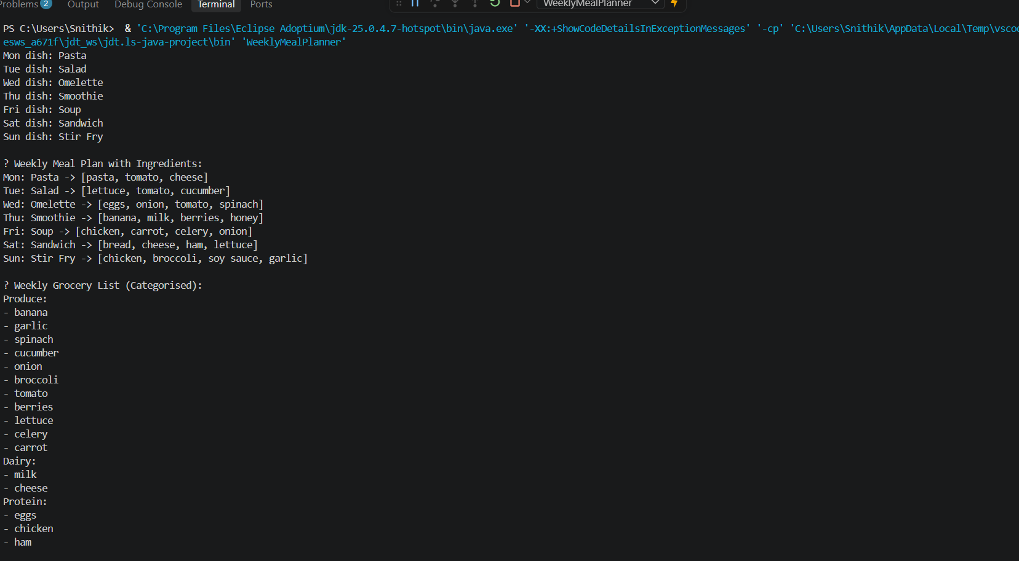
Conclusion
The Weekly Meal Planner & Grocery Generator project is a practical Java application that makes everyday life easier by combining meal planning with automated grocery list generation. It helps users stay healthy with balanced meals, saves time by eliminating daily cooking decisions, reduces costs by avoiding duplicate purchases, and improves organisation with categorised shopping lists.
By allowing day-wise meal entry and producing a consolidated grocery list, the program ensures convenience for individuals and families while encouraging sustainable habits like reducing food waste and using seasonal produce. Its adaptability makes it suitable for diverse lifestyles and dietary preferences.
Overall, this project demonstrates how thoughtful programming can directly improve daily routines, turning abstract coding concepts into a real-world solution that is efficient, organised, and user-friendly.

